Configuration of Node-Red to send commands to IBM cloud

ibmiot out node I used to send data from Node -Red to IBM Watson device. So, after adding it to the flow we need to configure it with credentials of our Watson device.

Here we add two buttons in UI

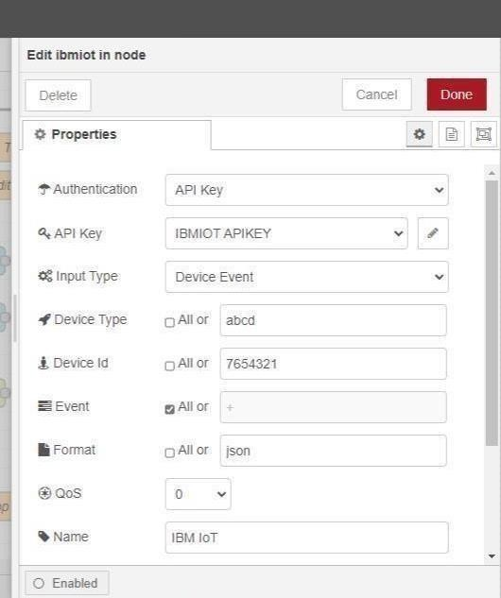

1 -> for motor on 2 -> for motor off

We used a function node toanalyses thedata received and assign command toeach number.

The Java script code for the analyses is: if(msg.payload===1) msg.payload={"com mand”: “ON"}; else if(msg.payload===0) msg.payload={"command”: “OFF"};

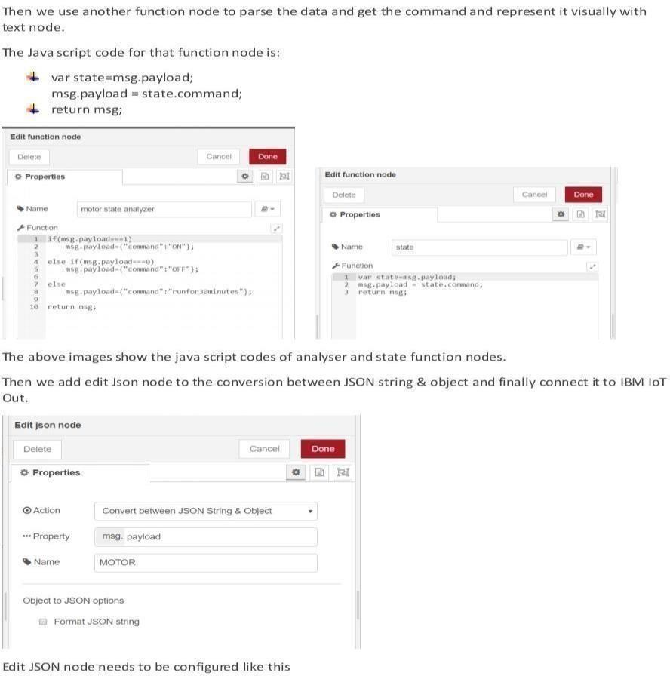

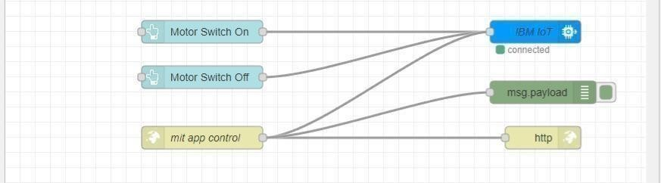

This is the program flow for sending commands to IBM cloud.

## Adjusting User Interface

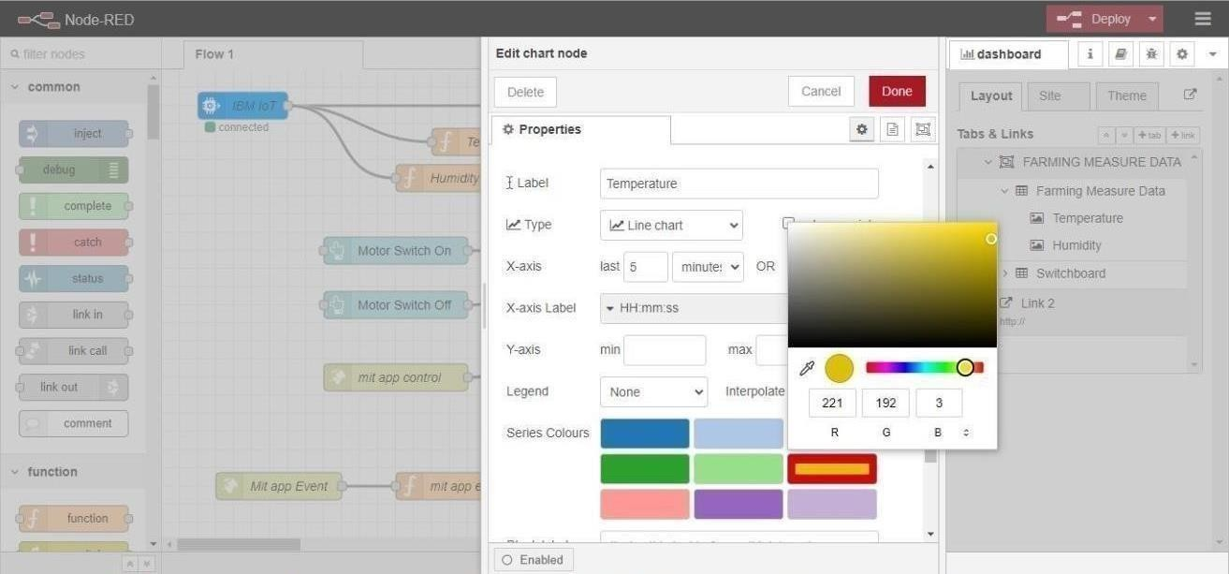

## Complete Program Flow

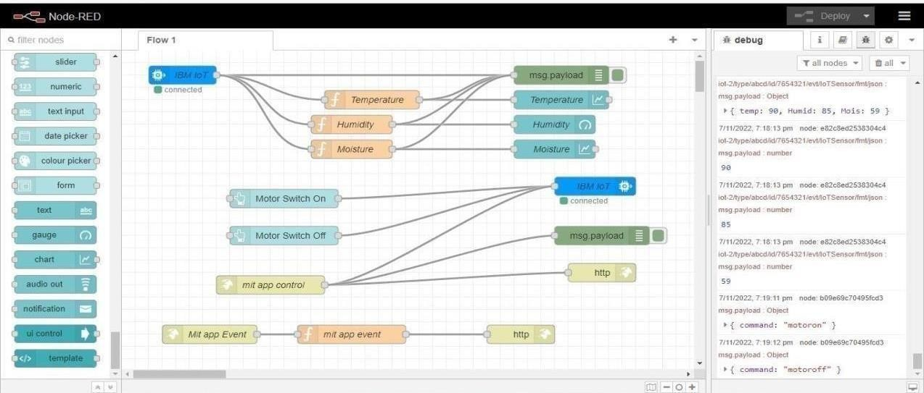

MOBILE APP WEB :

**BLOCK DIAGRAM**

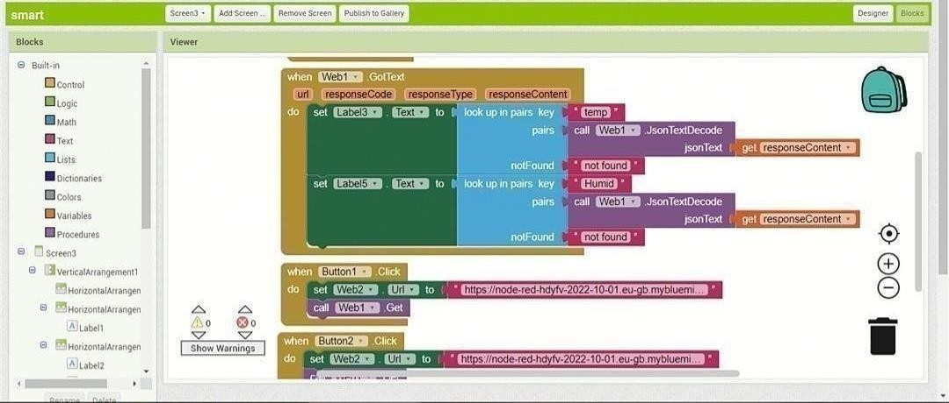

 

# SCREEN – 1 SCREEN - 2

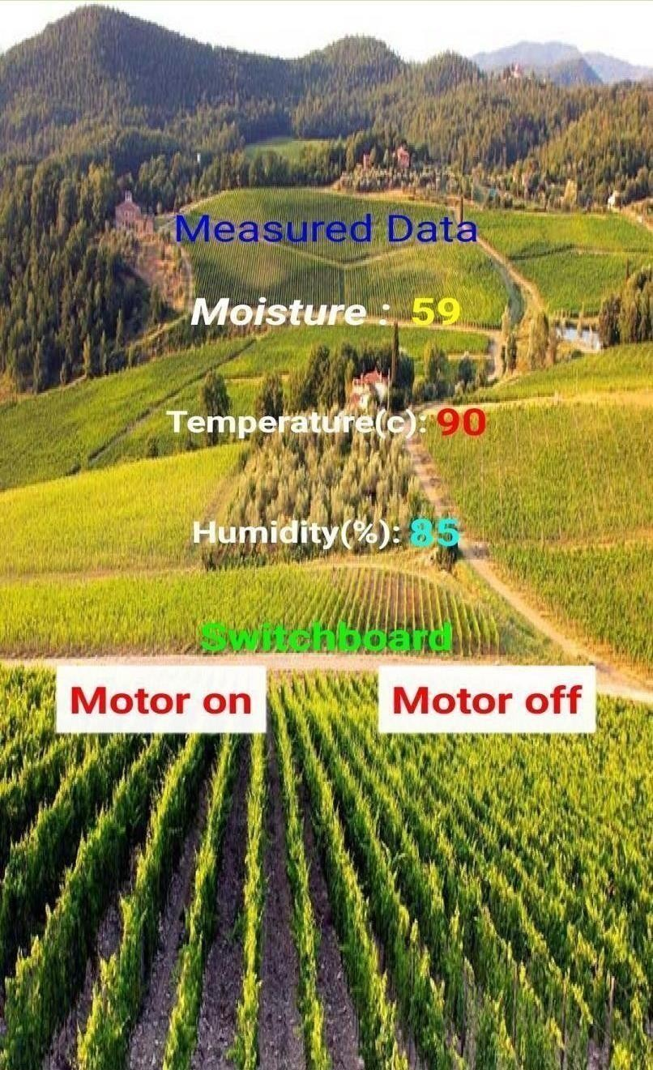

**SCREEN - 3**

## Web APP UI Home Tab

